METROLOGY for DRUG DELIVERY

2nd Newsletter

www.drugmetrology.com

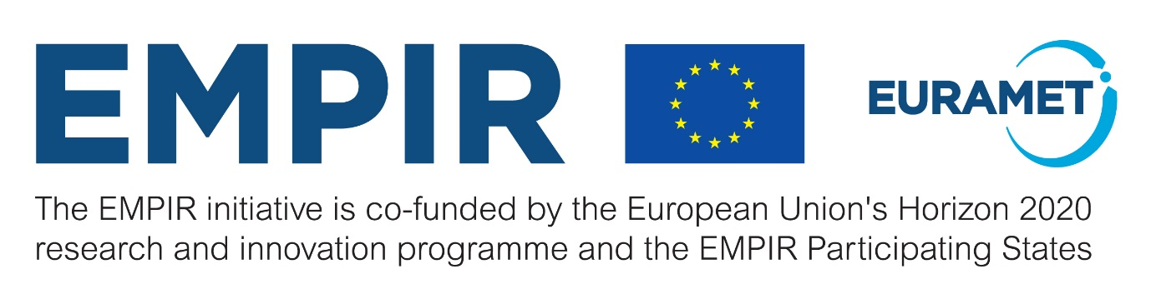
6 / 2020

Welcome
One year has passed since the beginning of the project and we welcome you with great pleasure to the second MeDDII newsletter. We take this opportunity to inform and update you about news, achievements and results of our work. In the first period of the project, the focus was on the development of new traceable techniques for the calibration of drug delivery devices in the measuring range from 5 nL/min to 100 nL/min, using Newtonian liquids. Stakeholders engagement in our project was intensified by establishing an advisory group. A questionnaire for technicians handling simple or multi-infusion setups and for manufacturer of drug delivery devices or components used in simple or multi-infusion setups was completed and 32 responses were received. Four research papers were published in Journal of Physics: Conference Series and in Flow Measurement Instrumentation magazine. Also, a case study entitled “COVID-19 crisis & Emergency Practices with Infusion Pumps in ICU, the role of Metrology” was published on our website in order to help hospital administrations to develop best practises and guidelines for new emergency COVID-19 drug delivery measures.We hope you will find valuable information in this newsletter. We are keen to keep in contact with you as stakeholders, users, or as someone generally interested in the work, and we are looking forward welcoming you in our project community.

Elsa Batista
Coordinator

News and facts
- A stakeholder advisory group was established in the project with the following members:
- Erik Koomen, anesthesiologist and pediatric intensivist on the Pediatric Intensive Care in Wilhelmina Children's Hospital Utrech in the Netherlands;
- Morten Kleinstrup from Phillips-Medisize A/S from Denmark;
- Anselmo Costa, head of the Pediatric Intensive care Unit from HGO in Caparica, Portugal;
- Stephanie Genay, expert in infusion device and on the composition of tubing from the University of Lille, France;
- Robert Butterfield – Expert in infusion technology, Biomedical engineer, USA.

- The second meeting was held at METAS, the National Metrology Institute from Switzerland, from 11 to 12 of February 2020.
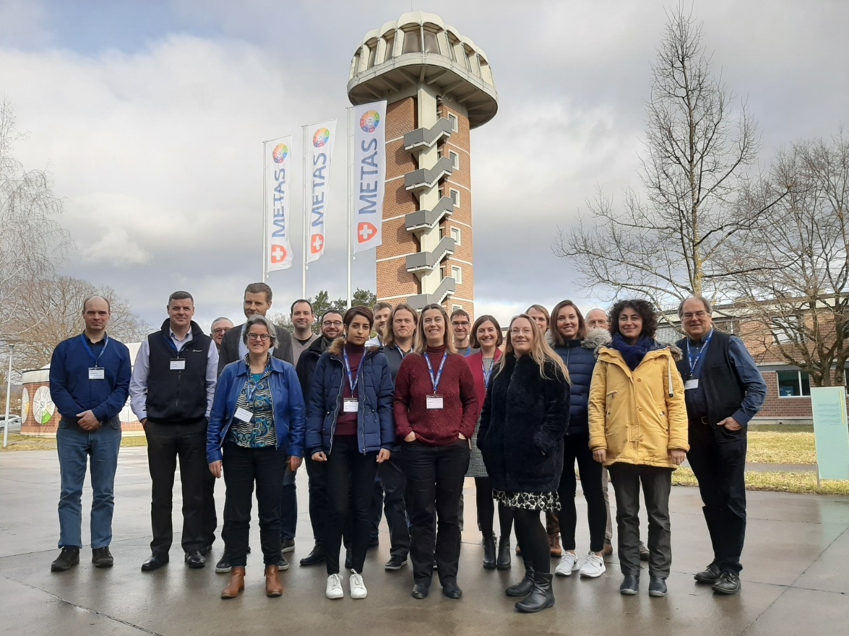
• A case study entitled “COVID-19 crisis & Emergency Practices with Infusion Pumps in ICU, The role of Metrology” was published on our website, you can find some more information here
• A report on Measurement error: two opposite definitions was published on our website, you can find some more information here
• The questionnaire for technicians handling simple or multi-infusion setups and for manufacturer of drug delivery devices or components used in simple or multi-infusion setups was completed and 32 responses were obtained. This information will be used in WP2, WP3 and WP4.

Highlights from the work packages
During this last year we have been very engaged in the development of new calibration methods and facilities, this work was mainly done under WP1 – Development of metrology infrastructure for ultra-low flow rates.
Different techniques are now under implementation by the different partners, mainly micro PIV, optical, displacement and gravimetric methods. By using different flow generators we were able to achieve various flows with different uncertainty levels: METAS is using a piston prover generating flow down to 20 nL/min with a relative uncertainty of 1 %; DTI is using a gravimetric method down to 16 nL/min with a 4 % relative uncertainty; IPQ developed an interferometric-based method that is able to measure flow down to 16 nL/min with a 3 % relative uncertainty; NEL and HSG-MIT are using an optical nanoflow measurement technique based on PIV, which is expected to go down to 1 nL/min but this is not yet achieved; CETIAT and THL have been extending the front track principle down to 1 nL/min with a 2.6 % uncertainty.

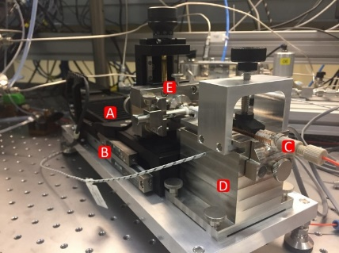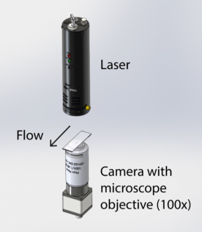

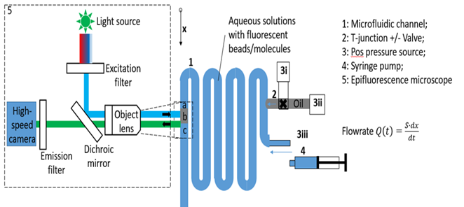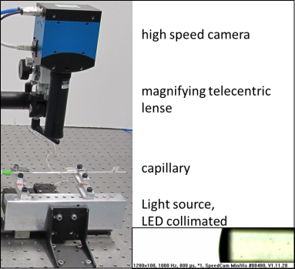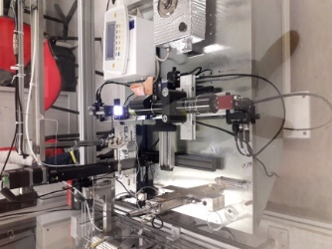

The uncertainty budgets are currently being developed for each method by the different partners.
After all facilities are completed an interlaboratory comparison will start in order to validate the developed measurement methods.

Under WP 2 – In-line measurement of the physical and thermodynamic proprieties of single and multicomponent liquids, two questionnaires for clinical users of multi-infusion setups, for technicians using multi-infusion setups and for manufacturers of drug delivery devices were developed and circulated, 33 responses were collected and this allowed us to identify the clinically relevant interval for the dynamic viscosities (< 2 mPa s), the flow rates (from 1 μL/min to 10 mL/min) and the liquids to be tested in the next task, namely saline solution, Dopamine and Dobutamine. The clinically relevant pressure interval was also identified, 0.1 bar to 0.5 bar, for occlusion alarms. Several in-line devices have been identified and will be used in the subsequent tasks.

In WP3 – Development of microchip pump and calibration procedures, the relevant types of drug delivery device and flowrate intervals to be tested have been identified based on the questionnaire response, mainly syringe pumps, infusion device analysers, insulin pumps and pain pumps. It is expected that the performance tests will start in September 2020 and these results will lead to the development of calibration procedures.
The initial diagrams of the microchip flow pump have been produced by INESC MN based on the specifications and they have been used as an input for numerical simulations, which are now concluded. The first physical prototype is expected to be produced until January 2021.

Finally, in WP 4 – Design and characterization of a multi-infusion system the clinical best practice guide using multi-infusion systems is under development, based on the answers from the questionnaires returned and the experience of UMC Utrecht.
The multi-infusion setups are under development according to the planned activities to build a setup for use in therapeutic activities. The predictive model of multi-infusion was extended to multiple flows and different viscosities. A second step will be to include the distortion of flow caused by mechanical obstruction due to components or air bubbles in line.

Dissemination of work
MeDDII experts are actively engaged with the impact on standardization namely ISO 8655 and ISO 23783 from ISOTC48, IEC60601-2-24 fromTC62/SC62D/MT23 and TUR 101 from AAMI.
A poster presentation was performed by Patricia A. G. Canane, Susana Cardoso, Vania Silverio, Biodetection and Diagnostics: Matching surface wettability to compatible Lab-on-chip technology, VIII AEICBAS Biomedical Congress, 12-15 March 2020
Four papers were published in several magazines, in open access, mainly:
- J A Sousa, E Batista, O Pellegrino, A S Ribeiro and L Martins, Method selection to evaluate measurement uncertainty in microflow applications, Journal of Physics: Conference Series, Volume 1379, Number 1, https://doi.org/10.1088/1742-6596/1379/1/012033
- E. Batista, et al, New EMPIR project – Metrology for Drug Delivery” published in Flow measurement instrumentation, 72 (2020) 101716, https://doi.org/10.1016/j.flowmeasinst.2020.101716
- H. Bissig, M. Tschannen, M. de Huu, Traceability of pulsed flow rates consisting of constant delivered volumes at given time interval, Flow measurement instrumentation, 73 (2020) 101729, https://doi.org/10.1016/j.flowmeasinst.2020.101729
- F.Ogheard, P.Cassette, A.W.Boudaoud, Development of an optical measurement method for “sampled” micro-volumes and nano-flow rates, 73 (2020), 101746, https://doi.org/10.1016/j.flowmeasinst.2020.101746
A Workshop on metrology for drug delivery will be help at CETIAT (1 day) in November 2020. More information will be available later in the MeDDII webpage.

How to contact us
MeDD II project coordination
Elsa Batista from IPQ
Email: ebatista@ipq.pt

Scientific leader
Hugo Bissig from METAS
Email: Hugo.bissig@metas.ch

Project website: www.drugmetrology.com
Zenodo: https://zenodo.org/communities/medd2

